|  |  |  |  |  |  |  |  |  |
| --- | --- | --- | --- | --- | --- | --- | --- | --- |
| **SVKM’S NMIMS** | | | | | | | | |
| **Mukesh Patel school of Technology Management & Engineering** | | | | | | | | |
| Programme: | | B TECH CE | | Year: | | II | Semester: | IV |
| **Academic Year : 2024-25** | | | | | | | | |
|  |  | |  | |  | |  |  |
| Subject: | Mobile Application Development | | | | | | Maximum Marks: | 10 |
|  |  | |  | |  | | Time: | 45 Min |
| Date: | 24/09/2024 | |  | |  | | Duration: | 3:30 to 4.30 pm |

Name: Chirag Vijayvergiya

Roll No: B215

SAP ID- 70022200211

Note :

* Assume necessary data if required.

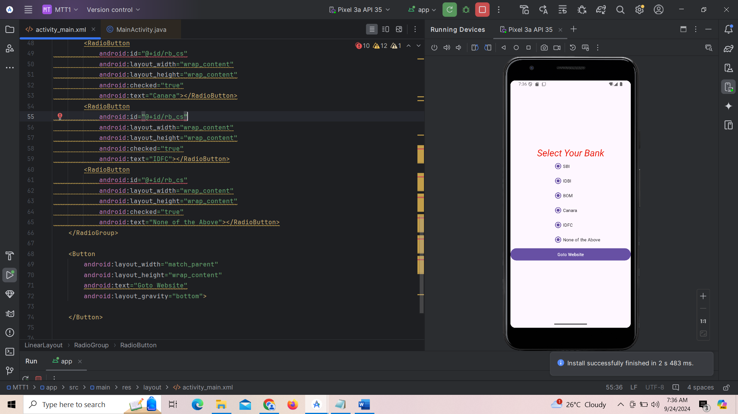 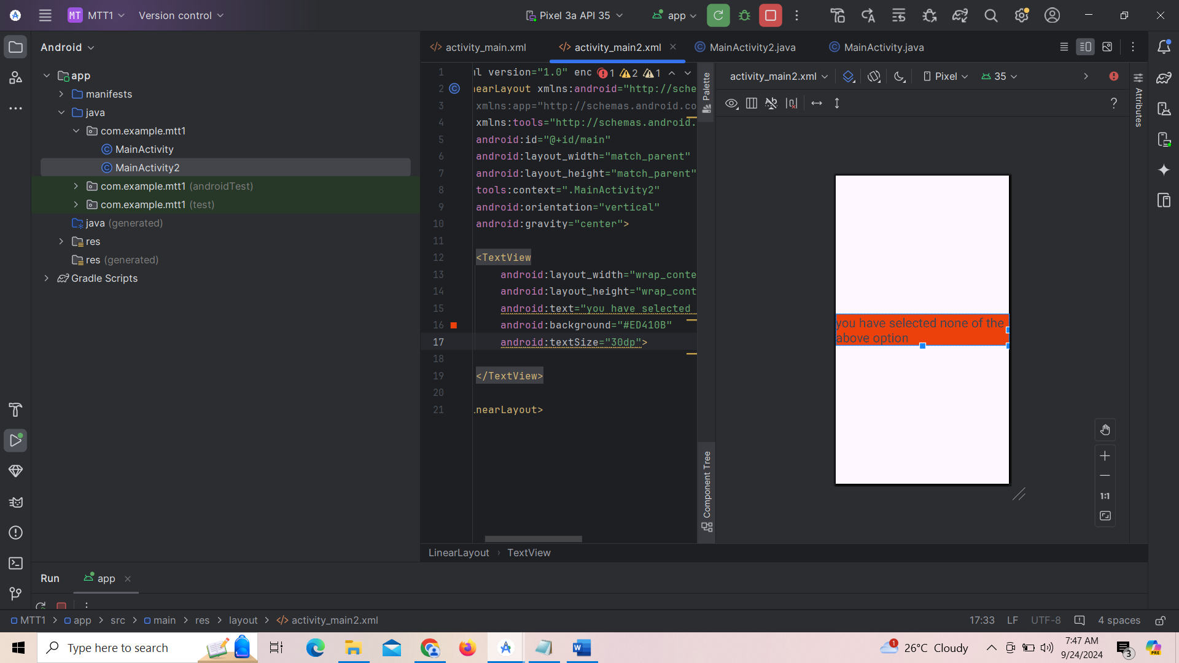

Figure 1 Figure 2

Q:

**Desing the activity, includes 6 radio button as per above figure1**

1. When any of radio button selected, display its text on toast
2. On Click of Goto Website button selected webpage should open on browser.
3. If None of the above is selected then goto second activity which will display “you have selected none of the above option” as per figure 2

|  |  |  |
| --- | --- | --- |
| **Question Number** |  | **Code & Output** |
| Q1 | **MainActivity.Java** | pasted-image.pngpasted-image.pngpasted-image.png |
|  | **Activity_main.xml** | pasted-image.pngpasted-image.pngpasted-image.pngpasted-image.png |
|  | **Striing.xml** | pasted-image.png |
|  | **Color.xml** | pasted-image.png |
|  | **Activity_main_2.xml** | pasted-image.png |
|  | MainActivity2.java | pasted-image.png |
|  | **O/P** | pasted-image.png  pasted-image.png |
|  | **O/P** |  |
|  | **O/P** | pasted-image.pngpasted-image.png |
|  | **O/P** | pasted-image.pngpasted-image.png |
|  | **O/P** | pasted-image.png |
|  | **O/P** | pasted-image.pngpasted-image.png |
|  | **O/P** |  |
|  | **O/P** |  |
|  | **O/P** |  |
|  | **O/P** |  |
|  | **O/P** |  |
|  | **O/P** |  |
|  | **O/P** |  |